SOLUTIONS OF THE PROBLEMS OF THE THEORETICAL COMPETITION

Problem 1 (10 points)
Problem 1.A 2012
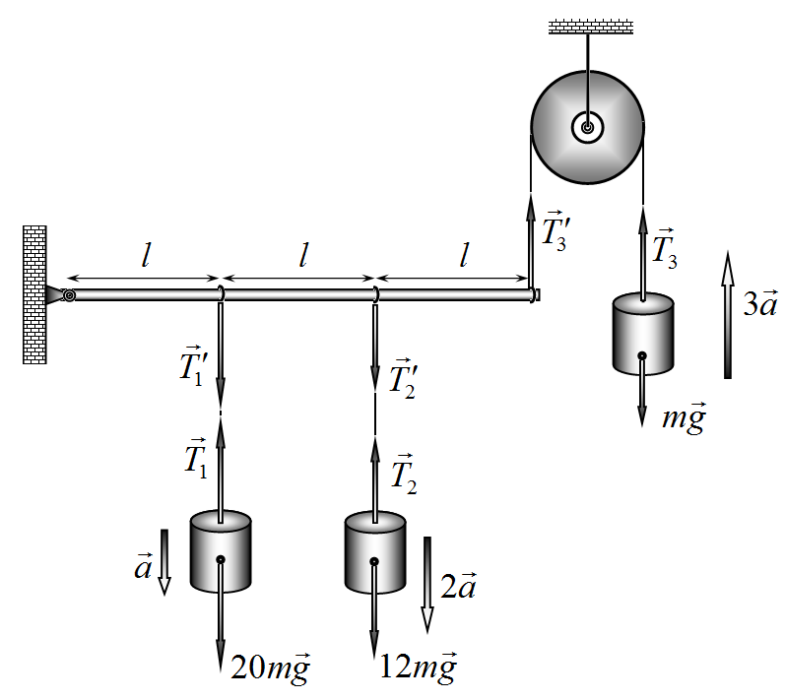
The forces acting on the system are shown in the figure on the right. Since the rod is rigid and weightless, the threads are inextensible and weightless, the accelerations of the weights are in a ratio 1:2:3. The net torque acting on a weightless rod should be equal to zero. These two conditions together with the equations of motion for all the weights are formally written as a set of equations
$\left\{\begin{matrix}\text{20}\text{ma}=\text{20}\text{mg}−T_{1} \\ \text{12}m⋅2a=\text{12}\text{mg}−T_{2} \\ m⋅3a=T_{3}−\text{mg} \\ T_{1}l+T_{2}⋅2l=T_{3}⋅3l\end{matrix}\right.$, (1)
from which we find
$a=\frac{\text{41}}{\text{77}}g$. (2)
However, it is seen that the acceleration of the weight with mass 12m appears to be $a=\frac{\text{82}}{\text{77}}g$ and larger than the acceleration of gravity. This means that the second thread will not be tight, thus the acceleration of the weight with mass 12m is equal to g. One can also show that the formal solution to the set of equations (1) yields $T_{2}<0$, that, of course, cannot happen with a thread. Therefore, the thread to which the second weight with mass 12m is suspended exerts no force on the rod. This means that the set of equations (1) incorrectly describes the system under consideration. To calculate the accelerations of the rod and the weights, the weight with mass 12m should be excluded from the analysis.
Correct values for the accelerations of the first and the third weights are obtained from the following set of equations
$\left\{\begin{matrix}\text{20}\text{ma}=\text{20}\text{mg}−T_{1} \\ m⋅3a=T_{3}−\text{mg} \\ T_{1}l=T_{3}⋅3l\end{matrix}\right.$. (3)
Finally, one gets
$a=\frac{\text{17}}{\text{29}}g$.
$a_{1}=\frac{\text{17}}{\text{29}}g$, $a_{2}=g$, $a_{3}=\frac{\text{51}}{\text{29}}g$. (4)

Grading scheme for Problem 1.A
№ |  | Points
1 | Figure with all the forces | 0,4
2 | The set of equations (1) | 0,8
3 | The solution of (1) to get the acceleration (2) | 0,4
4 | Exclusion of the weight with mass 12m from consideration | 0,3
5 | Prove the correctness of the exclusion (the acceleration of the weight with mass 12m is larger than g or the tension of the thread is negative) | 0,7
6 | Acceleration of the weight 12m is equal to g | 0,4
7 | The set of equations (3) | 0,6
8 | The solution to (3) for accelerations (4) | 0,4
 | Total | 4,0

Problem 1.B Diodes
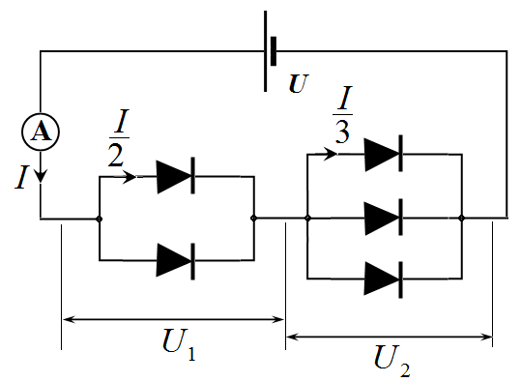
We denote the voltage drop on the pair of parallel-connected diodes by $U_{1}$ and on the three of parallel-connected diodes by $U_{2}$. The total current in the circuit $I$ can be found in two ways:
A double value of the current through one diode of the pair:
$I=2I_{0}\left(U_{1}\right)$; (1)

A triple value of the current through one diode of the triplet:
$I=3I_{0}\left(U_{2}\right)$. (2)
We construct the graphs of $2I_{0}\left(U\right)$ and $3I_{0}\left(U\right)$. It is enough to multiply points on the graph of the $I_{0}\left(U\right)$ by appropriate factors, i.e. for several values of the voltage one should read the currents, multiply them by factors 2 and 3 respectively, and plot the appropriate point on the graphs. When connected in series the total voltage is the sum of the voltages written as follows
$U_{1}+U_{2}=U$. (3)
Graphically, this condition corresponds to a “horizontal summation” of graphs $2I_{0}\left(U\right)$ and $3I_{0}\left(U\right)$: for a given value of the current the voltages $U_{1}$ and $U_{2}$ are read, and their sum is then taken to be plotted in the final graph.
Note that the formal solution of the problem can be written as (for the inverse functions):
$U\left(I\right)=U_{0}\left(\frac{I}{2}\right)+U_{0}\left(\frac{I}{3}\right)$,
where $U_{0}\left(I\right)$ is the function inverse to the graphically given function $I_{0}\left(U\right)$.

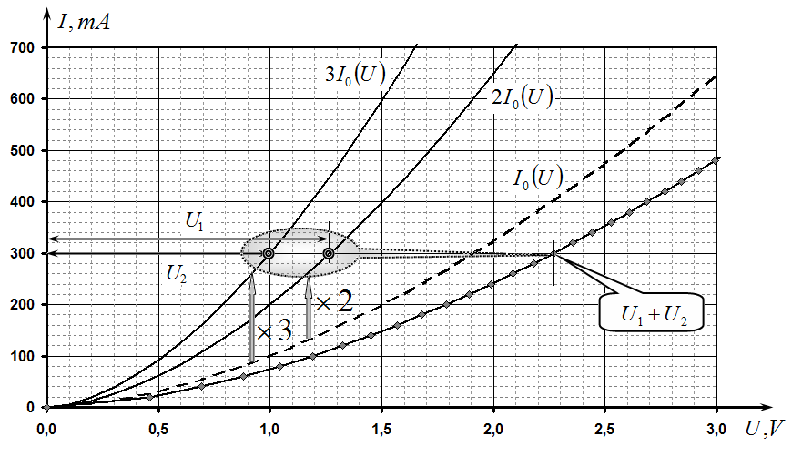

Grading scheme of Problem 1B
№ | Contents of number scores | Points
1 | In a parallel connection electric currents are summed | 0,3
2 | Plotting functions $2I_{0}\left(U\right)$ and $3I_{0}\left(U\right)$ | 0,6
3 | If a series connection the voltages are summed | 0,3
4 | “Horizontal” summation | 0,7
5 | Calculations are made for:  3 points;  6 points. | 0,3  0,6
6 | Alternatives (realized ideas):  To approximate the dependence;  To solve the equations explicitly; | 0,4  0,4
 | Total | 2,5

Problem 1.C. Flat lens

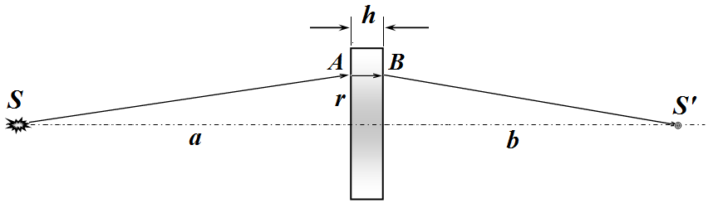
Plate will form an image $S^{'}$ if the optical path length ${l=\text{SAB \{}S}^{'}$ for any ray of light, emitted by the source and refracted in the plate, will be the same for all rays (tautochronism condition for a lens system).
Consider a ray incident on the plate at a distance r from its axis. We assume that $r\text{<<}a$, i.e. we make use of the paraxial approximation. The distance $\left|\text{SA}\right|$ is found using the Pythagorean theorem and making use of the approximation $r\text{<<}a$, we get:
$\left|\text{SA}\right|=\sqrt{a^{2}+r^{2}}=a\sqrt{1+\frac{r^{2}}{a^{2}}}≈a\left(1+\frac{1}{2}\frac{r^{2}}{a^{2}}\right)$, (1)
Similarly, the distance $\left|BS^{'}\right|$ is expressed as
$\left|BS^{'}\right|=\sqrt{b^{2}+r^{2}}=b\sqrt{1+\frac{r^{2}}{b^{2}}}≈b\left(1+\frac{1}{2}\frac{r^{2}}{b^{2}}\right)$. (2)
Thus, the optical path length ${\text{SAB \{}S}^{'}$ is equal to
$\begin{aligned}l=\left|\text{SA}\right|+n\left(r\right)h+\left|BS^{'}\right|=a\left(1+\frac{1}{2}\frac{r^{2}}{a^{2}}\right)+n_{0}\left(1−β r^{2}\right)h+b\left(1+\frac{1}{2}\frac{r^{2}}{b^{2}}\right)= \\ a+n_{0}h+b+\left(\frac{1}{2a}+\frac{1}{2b}−n_{0}βh\right)r^{2}\end{aligned}$. (3)
This value does not depend on $r$ (i.e., the same for all rays) if the following condition is satisfied
$\frac{1}{2a}+\frac{1}{2b}−n_{0}βh=0$, (4)
which can be rewritten as
$\frac{1}{a}+\frac{1}{b}=2n_{0}βh$. (5)
This expression is identical in form to a thin lens formula
$\frac{1}{a}+\frac{1}{b}=\frac{1}{F}$, (6)
with the focal length F.
Comparing (5) and (6), we find the focal length of the plate
$F=\frac{1}{2n_{0}β h}$. (7)
From formula (5) one also finds the distance from the plate to the image:
$b=\frac{a}{2n_{0}β\text{ha}−1}$. (8)
The alternative is a geometrical optics approximation.
This problem, in principle, can be solved in the framework of geometrical optics. The main stages of this very complex solution are:
- Use the law of refraction of Snellius;
- Choose an arbitrary ray and determine the angle of incidence on the plate;
- Determine an angle of the ray after the refraction at the front plane of plate;
- Obtain a differential equation for the ray path inside the plate;
- Solve this equation in the quadratic approximation;
- Determine the angle at the front plane of the plate (should be negative);
- Determine the angle after the refraction at the rear plane;
- Determine the distance to the intersection point with the axis of the plate;
- Proove that the distance is the same for any ray;
- Get the lens formula;
- Write the formula for the focal length.

Grading scheme of Problem 1C
№ |  | Points
1 | Formulation of basic idea: the constancy of the propagation time for all paths | 1,5
2 | Using the quadratic approximation (for small angles) | 0,5
3 | Calculation of distances $\left|\text{SA}\right|$ and $\left|BS^{'}\right|$  - The exact formula;  - And its expansion; | 0,2  0,4
4 | The optical path length (3) | 0,2
5 | A formula of a thin lens (4) | 0,3
6 | Focal length of lens (7) | 0,2
7 | Distance to the image (8) | 0,2
 | Total | 3,5

Grading for geometrical optics approximation (alternative solution)
№ |  | Points
1 | The refraction law | 0,4
2 | Two small-angle approximation (but quadratic) | 0,4
3 | The starting angle at the plate | 0,2
4 | The differential equation for the ray trajectory in the plate | 0,7
5 | The solution in a quadratic approximation | 0,6
5 | The value of the angle near the rear plane | 0,2
6 | The value of the angle after refraction at the rear plane | 0,2
7 | The point of intersection with the optical axis | 0,2
8 | Invariance of distance b for all refracted rays | 0,2
9 | Formula analogous to a thin lens | 0,2
10 | The formula for the focal length | 0,2
 | Total | 3,5

Problem 2
Adventures of a piston (10 points)
2.1 [0.5 points] From the equilibrium condition of the piston, we find the gas pressure
Pa. (1)
2.2 and 2.3 [2 points] In the first stage the gas is compressed and heats up to a certain temperature. Because the vessel’s walls and the piston are made of a material that conducts heat poorly, the gas compression can be assumed to be adiabatic, but the process is not quiasistatic and one cannot use the adiabatic equation. In the transition from the initial to the final state of the system piston+gas, external forces (gravity and the atmospheric pressure) have done the work
, (2)
By the assumption in the formulation, only a half of this work is spent to increase the internal energy of the gas
, (3)
where
, (4)
Here, is the number of moles.
We write the equation of state of ideal gas for the initial and final states
, (5)
. (6)
Solving the set of equations (2)−(6), we obtain
K, (7)
cm. (8)
2.4 [0.5 points] Since the piston is still in equilibrium, the pressure equals
Pa. (9)
2.5 [0.5 points] After a sufficiently long period of time the gas temperature inside the vessel will be equal to the ambient temperature, i.e., becomes equal to
К. (10)
2.6 [0.5 points] The height is found from (9) and (10), as well as from the equation of state
cm. (11)
2.7 [2 points] An adiabatic equation of state has the form
, (12)
we obtain
. (13)
Let a piston deviate from its equilibrium position at a small height x, then, according to (13), the pressure change is equal to
. (14)
The equation of motion of the piston can be written as
, (15)
whence we obtain the frequency of small oscillations
Hz. (16)
2.8 [1 point] When moving with the constant velocity, the piston remains in equilibrium, so the pressure can be written as
Pa, (17)
that is
, (18)
2.9 and 2.10 [3 points] Suppose a steady temperature has established in the vessel. The balances both in the number of particles and the energy should be achieved.
The law of conservation of particle number is given by
. (19)
In the conservation of energy it is necessary to take into account not only the translational kinetic energy but also the rotational energy of each molecule. Therefore, the total energy carried by each molecule is
. (20)
Then, the energy conservation law can be written as
. (21)
Solving (18) and (19), we finally obtain
m/s, (22)
that is
, , (23)
and the temperature is
K, (24)
that is
, . (25)

Grading scheme of Problem 2
N |  | Points
2.1 | Formula (1) | 0,25 | 0,5
 | Numerical value of | 0,25 | 0,5
2.2 | Formula (2) | 0,25 | 1,5
 | Formula (3) | 0,25 | 1,5
 | Formula (4) | 0,25 | 1,5
 | Formulas (5) and (6) | 0,25 | 1,5
 | Formula (7) | 0,25 | 1,5
 | Numerical value of | 0,25 | 1,5
2.3 | Formula (8) | 0,25 | 0,5
 | Numerical value of | 0,25 | 0,5
2.4 | Formula (9) | 0,25 | 0,5
 | Numerical value of | 0,25 | 0,5
2.5 | Formula (10) | 0,25 | 0,5
 | Numerical value of | 0,25 | 0,5
2.6 | Formula (11) | 0,25 | 0,5
 | Numerical value of | 0,25 | 0,5
2.7 | Formula (12) | 0,25 | 2,0
 | Formula (13) | 0,25 | 2,0
 | Formula (14) | 0,5 | 2,0
 | Formula (15) | 0,5 | 2,0
 | Formula (16) | 0,25 | 2,0
 | Numerical value of | 0,25 | 2,0
2.8 | Formula (18) for | 0,25 | 1,0
 | Formula (18) for | 0,25 | 1,0
 | Formula (17) | 0,25 | 1,0
 | Numerical value of | 0,25 | 1,0
2.9 | Formula (19) | 0,25 | 2,0
 | Formula (20) | 0,5 | 2,0
 | Formula (21) | 0,25 | 2,0
 | Formula (23) for | 0,25 | 2,0
 | Formula (23) for | 0,25 | 2,0
 | Formula (22) | 0,25 | 2,0
 | Numerical value of | 0,25 | 2,0
2.10 | Formula for (25) for | 0,25 | 1,0
 | Formula for (25) for | 0,25 | 1,0
 | Formula (24) | 0,25 | 1,0
 | Numerical value of | 0,25 | 1,0
Total |  |  | 10,0

Problem 3
Nuclear droplet (10 points)
3.1 [2 points] Let us calculate the total electrostatic energy of the protons in the nucleus. Within the droplet model the nuclear charge is uniformly distributed inside a ball of radius , so that its volume density is the same everywhere and equals to
. (1)
Using the Gauss theorem, we find the electric field inside and outside of the ball
, (2)
. (3)
Hence we get
. (4)
Total electrostatic energy is given by the integral
. (5)
3.2 [1 point] From (5), and one can see that the electrostatic energy corresponds to the third term in the Weizsacker semiempirical formula, so
, (6)
whence
m. (7)
3.3 [1 point] The density of the nuclear matter is given by
kg/m³. (8)
3.4 [1 point] The surface energy depends on the surface tension
. (9)
We conclude that the surface energy corresponds to the second term of the semi-empirical formula of Weizsäcker
, (10)
whence
N/m. (11)
3.5 [2 points] Nuclear fission becomes exoteric only if the potential energy of the nuclei decreases, that is,
, (12)
which yields
. (13)
Graph of the function is presented below.
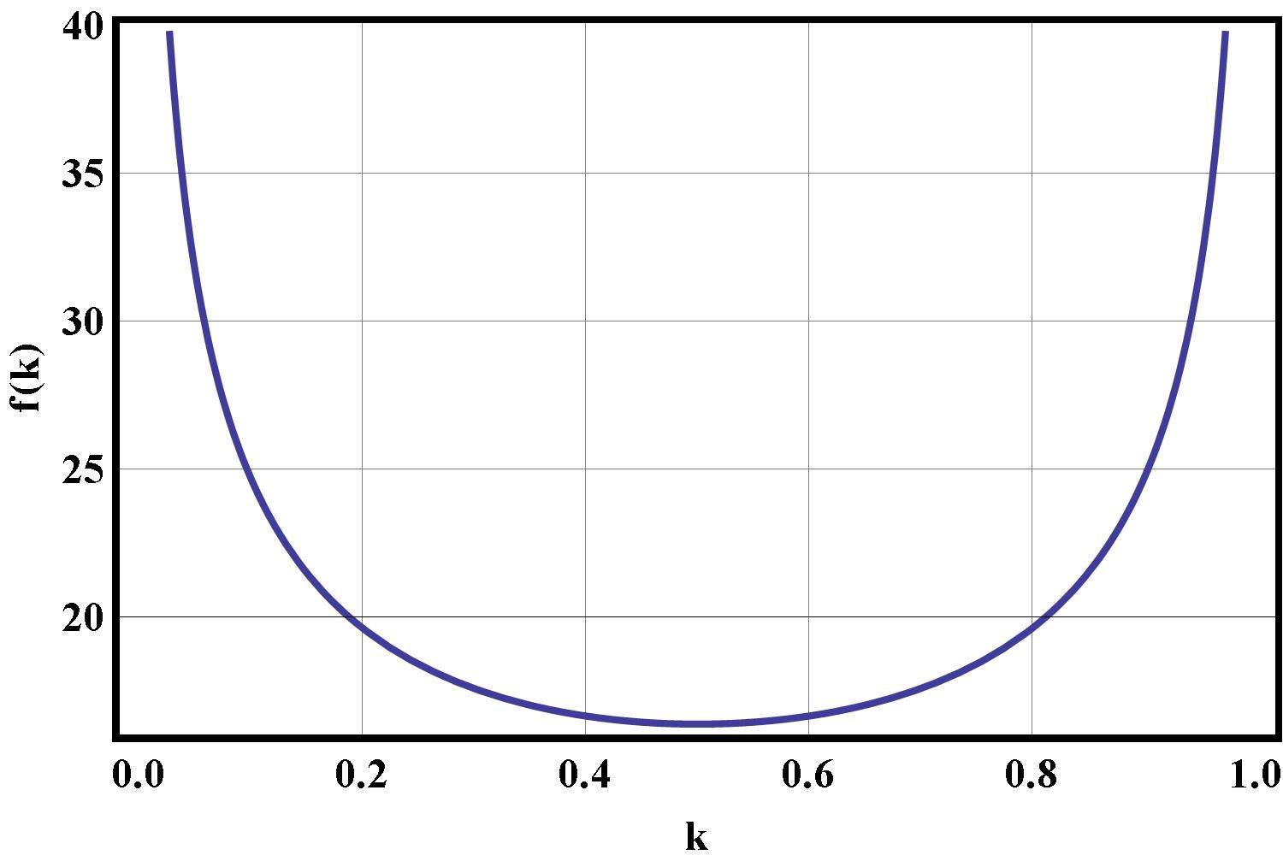
3.6 [0.5 points] The function is symmetric with respect to the point , so the minimum is achieved exactly at this point, which corresponds to
. (14)
3.7 [0.5 points] Since the nucleus is treated as a liquid, its volume should not change. Using the formula for the volume of an ellipsoid and the fact that we obtain
, (15)
whence
. (16)
3.8 [2 points] Using Taylor's series expansion for small deformations of the nucleus and taking into account (16), the surface area of the liquid increases by
, (17)
and an increase in the surface energy is equal to
. (18)
The Coulomb interaction energy of the protons is decreased by the value
. (19)
A nucleus is unstable under the condition
, (20)
whence
. (21)

Grading scheme of Problem 3
N |  | Points
3.1 | Formula (1) | 0.5 | 2.0
 | Formula (2) | 0.5 | 2.0
 | Formula (3) | 0.5 | 2.0
 | Formula (5) | 0.5 | 2.0
3.2 | Formula (6) | 0.5 | 1.0
 | Formula (7) | 0.25 | 1.0
 | Numerical value of | 0.25 | 1.0
3.3 | Formula (8) | 0.75 | 1.0
 | Numerical value of | 0.25 | 1.0
3.4 | Formula (9) | 0.25 | 1.0
 | Formula (10) | 0.25 | 1.0
 | Formula (11) | 0.25 | 1.0
 | Numerical value of | 0.25 | 1.0
3.5 | Formula (12) | 0.5 | 2.0
 | Formula (13) | 0.5 | 2.0
 | Plot: X axis symbol indicated | 0.25 | 2.0
 | Plot: Y axis symbol indicated | 0.25 | 2.0
 | Plot: k shown from 0 to 1 | 0.25 | 2.0
 | Plot: appropriate values on plot | 0.25 | 2.0
3.6 | Appropriate value of k | 0.25 | 0.5
 | Appropriate value of | 0.25 | 0.5
3.7 | Formula (15) | 0.25 | 0.5
 | Formula (16) | 0.25 | 0.5
3.8 | Formula (17) | 0.5 | 2.0
 | Formula (18) | 0.25 | 2.0
 | Formula (19) | 0.25 | 2.0
 | Formula (20) | 0.5 | 2.0
 | Formula (21) | 0.25 | 2.0
 | Numerical value of | 0.25 | 2.0
Total |  |  | 10.0

